Project in Android Studio realised by DOUCOURE OUSSY and AGHZOU SAID
Under the defense of sir
Manos
Katsomallos
/ Dimitris Kotzinos

Email of :
Doucoure:oussydoucoure96@gmail.com
Aghzou:saghzou96@gmail.com

Describing the project :

An app that stores usernames/passwords for other applications and web sites; added capability to be invoked when a password is to be stored (e.g. by a web browser).
One activity used to login in the app and another to display the saved passwords and another to insert a new username/password/application set.

To create this application, we had used a database MySql to store and extract informations about username, password, name and age.It is accessible on the Url :https://www.000webhost.com/cpanel-login?from=panel with the username :saghzou96@gmail.com and password:TABLABAÇ-.The important table is ‘user’ to resolve informations.

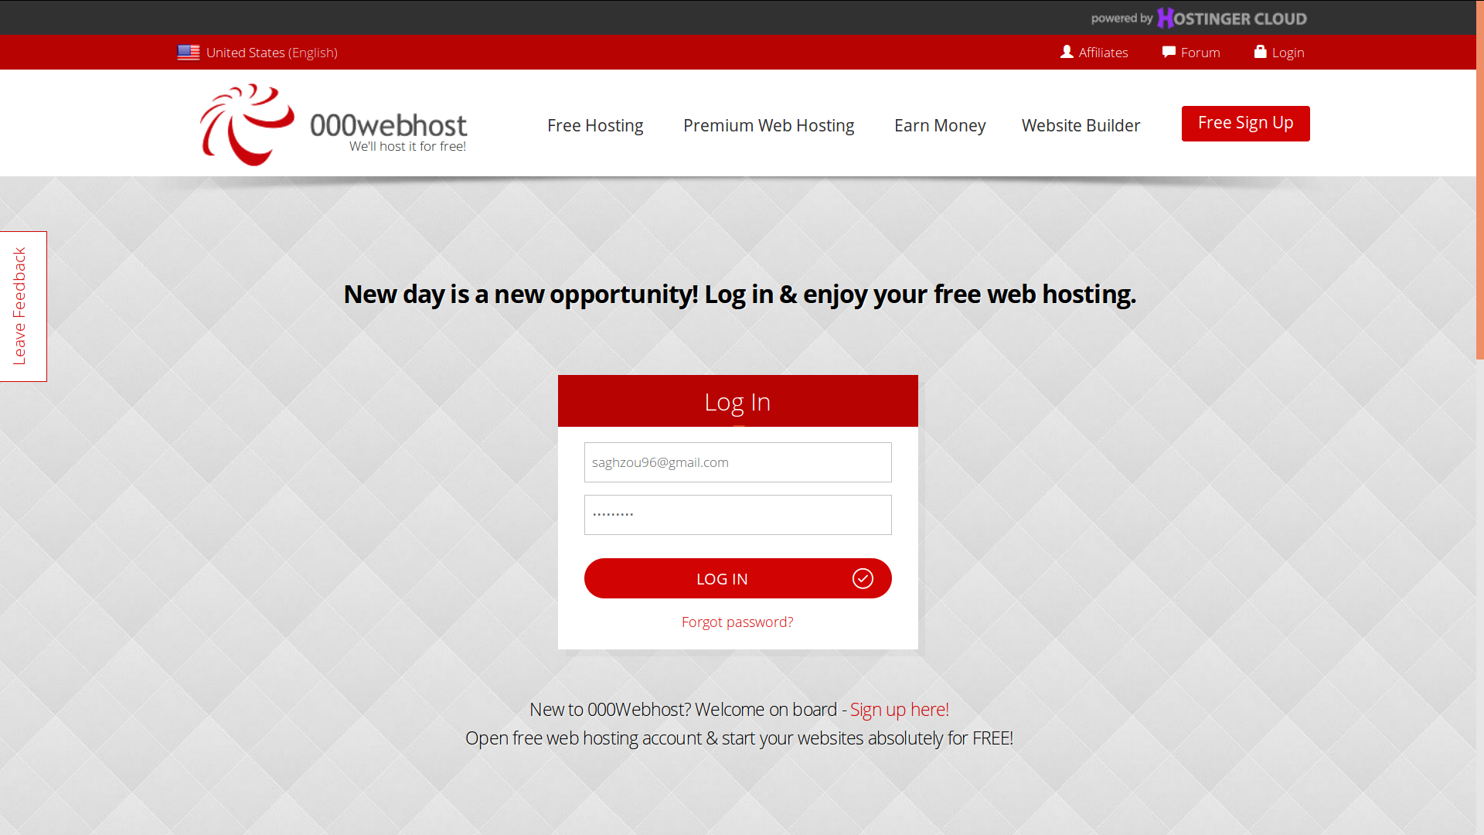

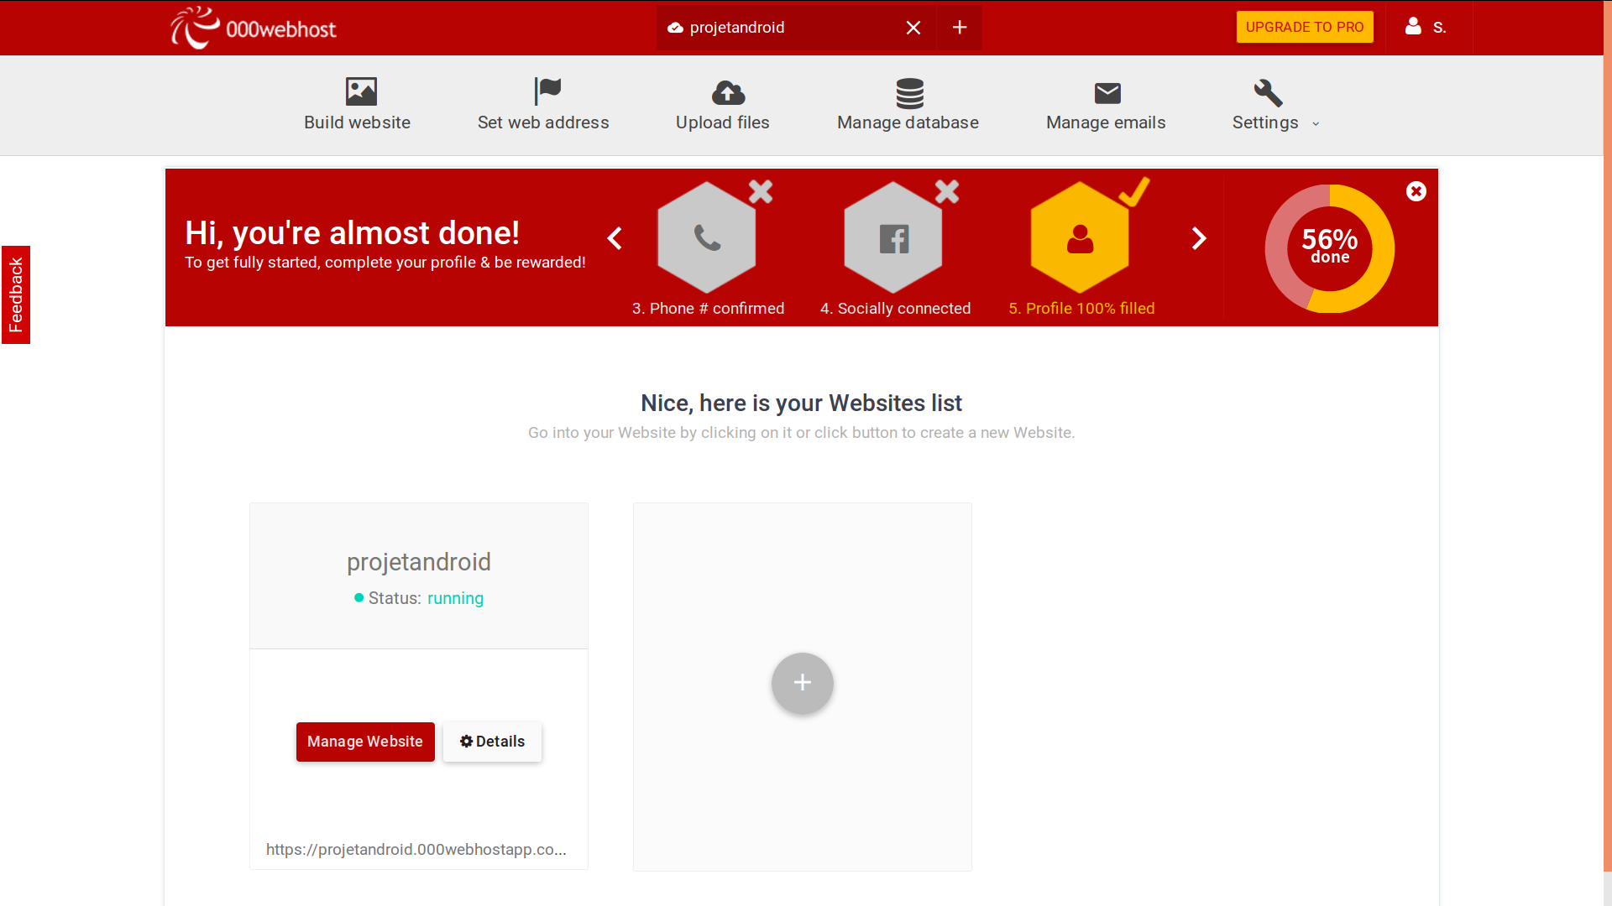

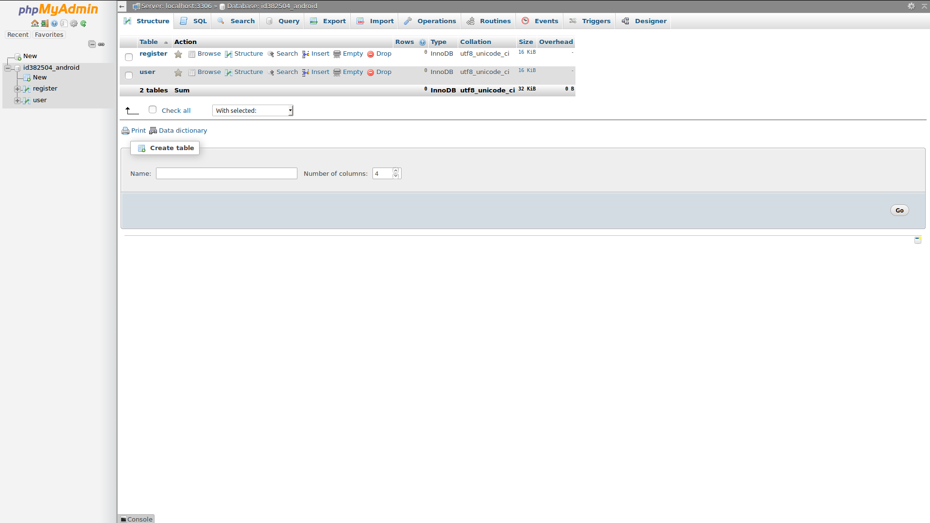
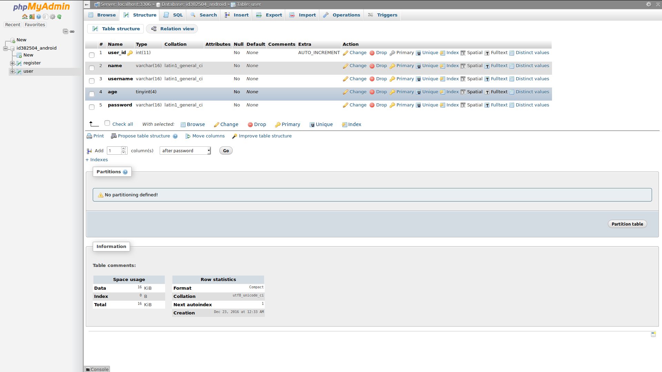

Classes :

RegisterActivity.java :
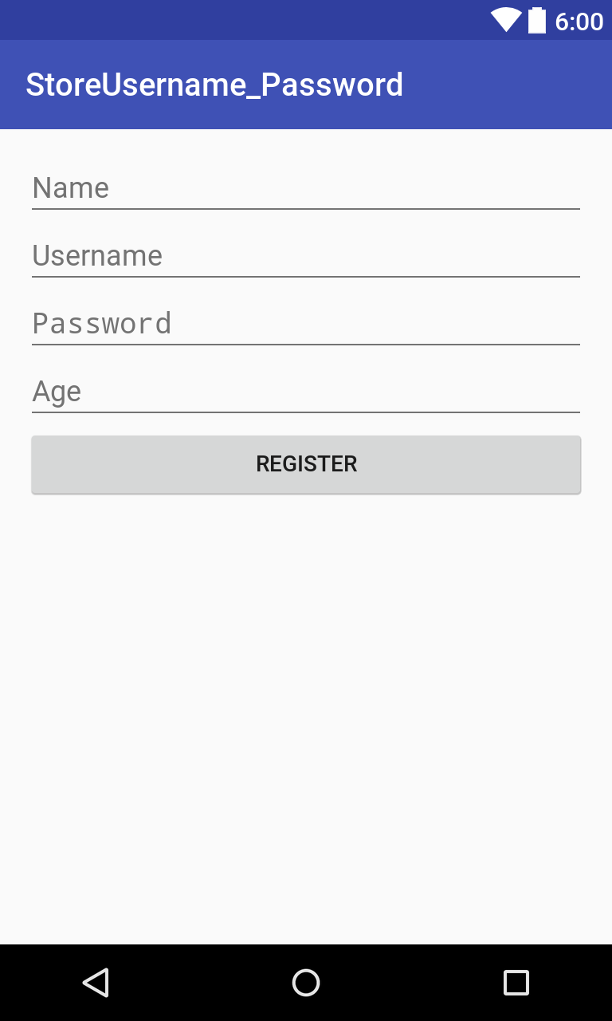

contains methods to get the information enter by the user when he clicks on «Register Here » in the main class which is LoginActivity.java.

final EditText etAge = (EditText) findViewById(R.id.etAge);
final EditText etName = (EditText) findViewById(R.id.etName);
final EditText etUsername = (EditText) findViewById(R.id.etUsername);
final EditText etPassword = (EditText) findViewById(R.id.etPassword);
final Button bRegister = (Button) findViewById(R.id.bRegister);
This data store in the database by using this code :

RegisterRequest registerRequest = new RegisterRequest(name, username, age, password, responseListener);
RequestQueue queue = Volley.newRequestQueue(RegisterActivity.this);
queue.add(registerRequest);
This class helps the user to login without inscription another time.
RegisterRequest.java :
It contains the URL of the register’s file that allows to access to database and store the data.
private static final String REGISTER_REQUEST_URL="https://files.000webhost.com/Register.php";

LoginActivity .java :

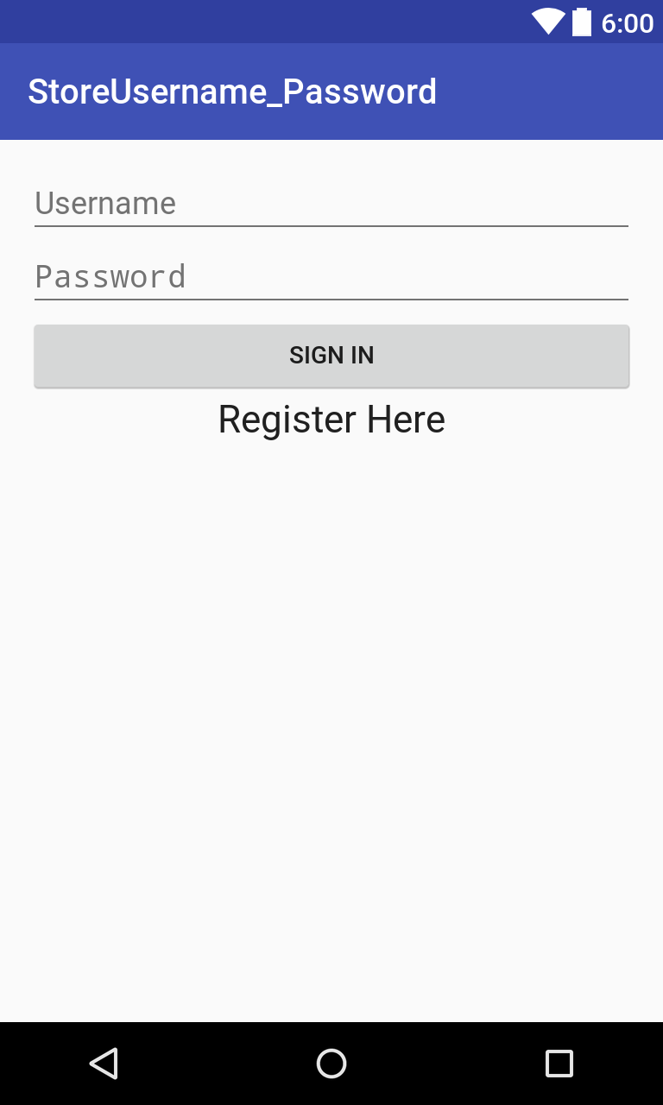

After inscription, the user pass to login, so this class get the text of username and password entering by the user, then a method test if this two last parameters had already registred in the the database, if
is true so they launch a new activity that give in a new interface the rest of information about the user like hid age and again his username, this last interface represent UserAreaActivity.java .If is false, a builder show message of login failed and give a button to retry the login.

if (success) {
String name = jsonResponse.getString("name");
int age = jsonResponse.getInt("age");
Intent intent = new Intent(LoginActivity.this, UserAreaActivity.class);
intent.putExtra("name", name);
intent.putExtra("age", age);
intent.putExtra("username", username);
LoginActivity.this.startActivity(intent);
} else {
AlertDialog.Builder builder = new AlertDialog.Builder(LoginActivity.this);
builder.setMessage("Login Failed")
.setNegativeButton("Retry", null)
.create()
.show();
}
to access to the database we had used this code for storing the data :
LoginRequest loginRequest = new LoginRequest(username, password, responseListener);
RequestQueue queue = Volley.newRequestQueue(LoginActivity.this);
queue.add(loginRequest);

LoginRequest.java :
It contains the URL that allows to access to database for testing if username/passeword entered by the user was stored in the database or not.
private static final String LOGIN_REQUEST_URL="https://files.000webhost.com/login.php";

UserAreaActivity.java :

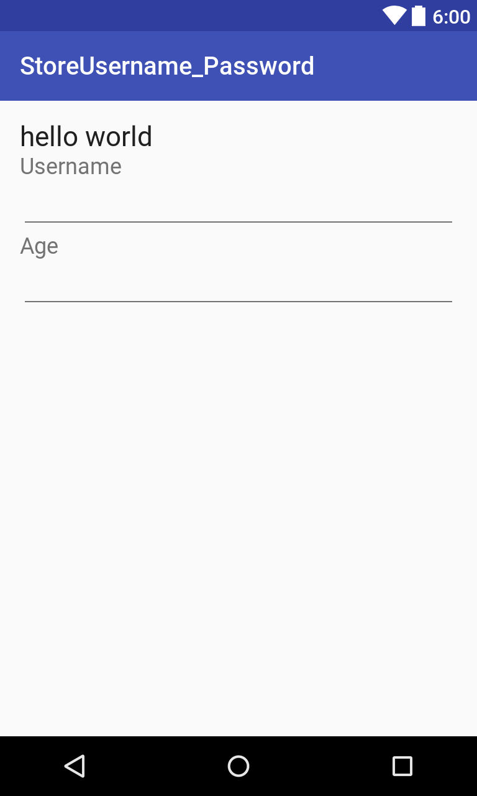

this inteface is getting after the login is successful, it gives the username ,age and a message by this finale code
// Display user details
String message = name + " welcome to your user area";
tvWelcomeMsg.setText(message);
etUsername.setText(username);
etAge.setText(age + "");
The location of the two file in the data base :
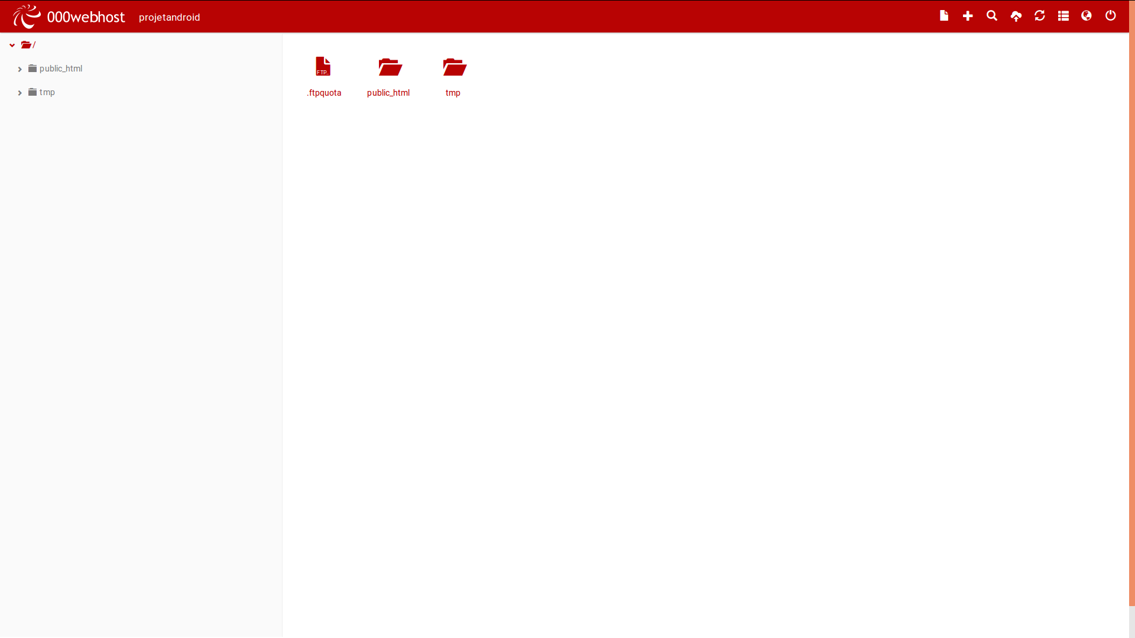
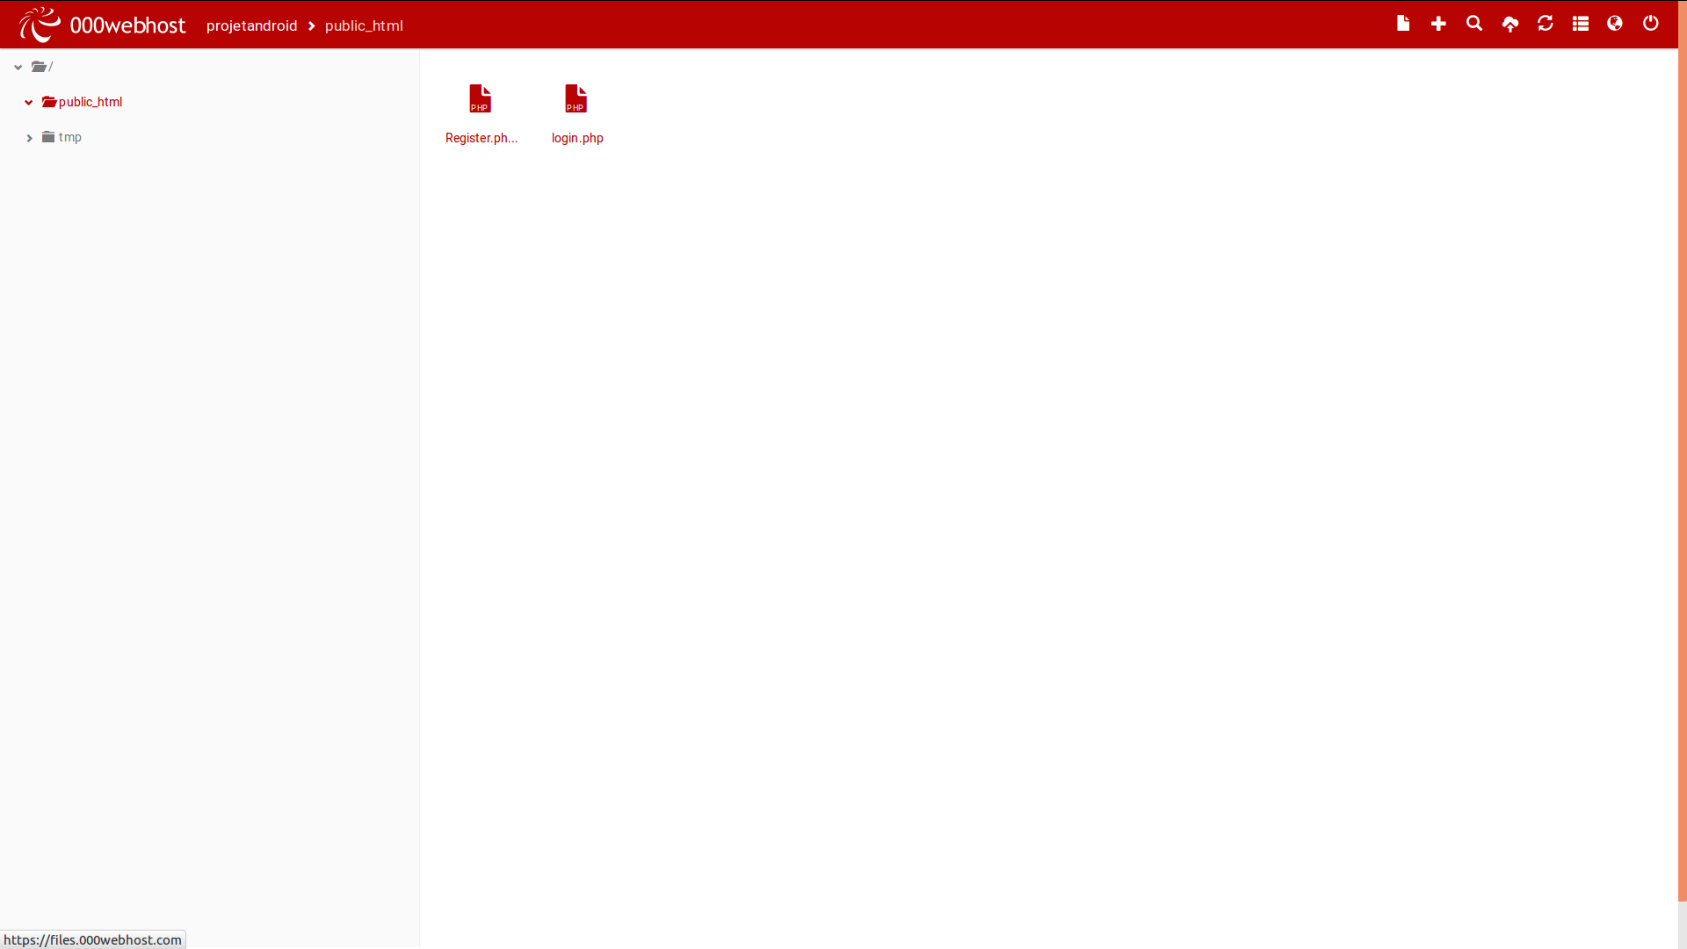
File AndroidManifest.xml :
we had added the permission INTERNET to have access to the databse
<uses-permission android:name="android.permission.INTERNET" />

in Build.gradle :
We had added the library Volley that facilitates Android network calls
compile 'com.android.volley:volley:1.0.0'

The source of the code :
We has used Youtube by Watching different Android Studio Tutorial for Activity, Server and the Database.

